**R Code for Examples in the book**

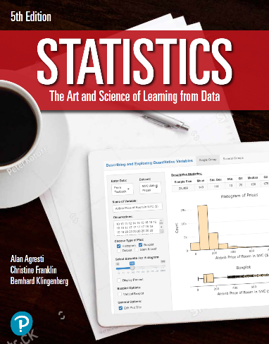

***“Statistics: The Art and Science of Learning from Data”***

**by Agresti, Franklin and Klingenberg, 5th edition**

**Chapter 12**

**Example 2: The Strength Study – Scatterplot**

## Reading in data

athletes <- read.csv(file='https://raw.githubusercontent.com/artofstat/data/master/Chapter12/highschool_female_athletes.csv')  
colnames(athletes) #check column names

## [1] "Athlete" "BP60" "maxBP..lbs."   
## [4] "LP200" "maxLP..lbs." "Situps..per.minute."  
## [7] "X40YD..sec." "VerticalJump..in." "SitReach..in."   
## [10] "MB..in." "SR..sec." "Age"   
## [13] "Height..in." "Weight..lbs." "Bodyfat...."   
## [16] "BMI" "Sport"

attach(athletes) # so we can refer to variable names

## 

## To create a scatterplot

plot(x = BP60, y = maxBP..lbs., pch = 16, col = 'darkred',  
 main = 'Data on 57 Female High School Athletes',  
 xlab = 'Number of 60 lbs. Bench Presses',  
 ylab = 'Maximum Bench Press (lbs)')

